1. Programe to serch for a particular character in string

str = "javascript tutorial teach by lets upgrade";

char = "i";

if(str.indexOf(char)){

    console.log("Element if found at index: ",str.indexOf(char))

}else{

    console.log("Element if not found ")

}

Output:

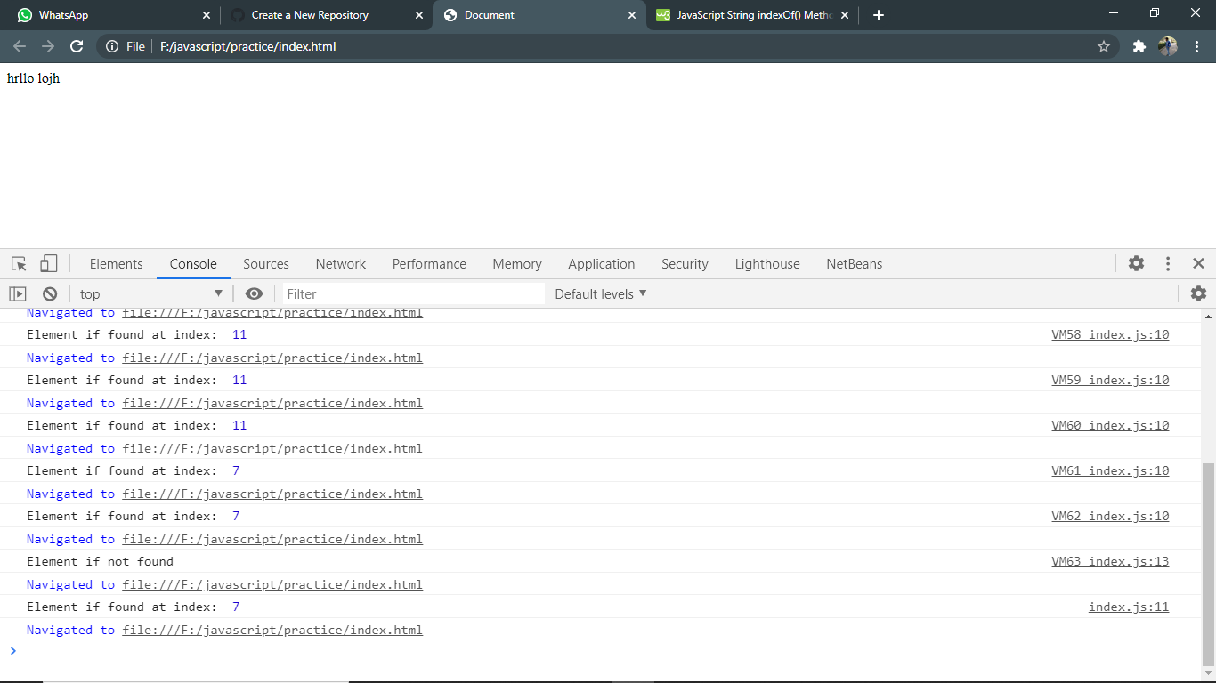

2.program to Convert minutes in seconds

function mintosec(n){

    sec = n\*60;

    console.log(`in ${n} Minutes ${sec} Second`);

}

mintosec(10)

Output:

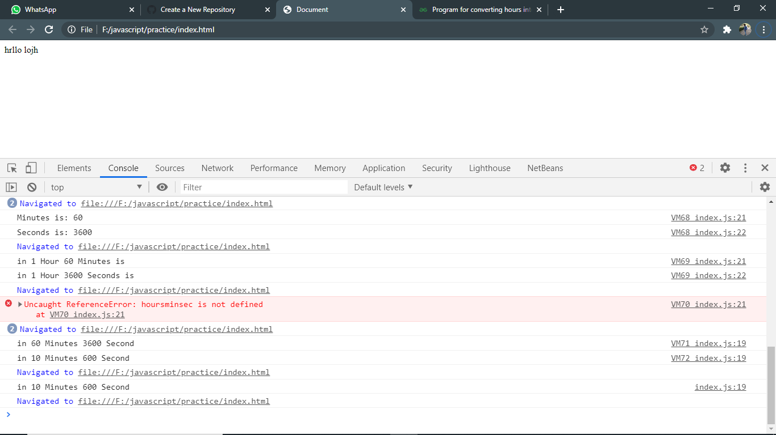

3. program to search for a element in array of string

isfound = false

const findstr = (arr, ele) => {

    for (i = 0; i < arr.length; i++) {

        if (arr[i] == ele) {

            isfound = true;

            return i;

        }

    }

}

arr = ["lets", "Upgrade", "javascript", "pro", "learning", "webtech", "apple"];

ele = "javascript

ret = findstr(arr, ele);

if (isfound) {

    console.log(`Element ${ele} found at : ${ret}`);

} else {

    console.log(`Element ${ele} not found`);

}

Output:

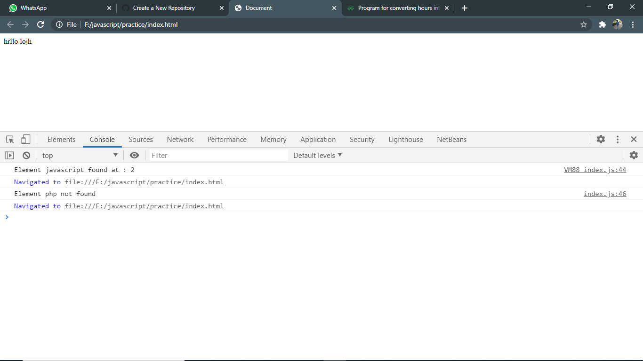

4. program to display element containing “a” from array

arr = ["lets","Upgrade","javascript","pro","learning","webtech","apple"];

arr.forEach(element => {

    if(element.indexOf("a") >=0){

        console.log(`Element containing Char A is ${element}`);

    }

});

Output:

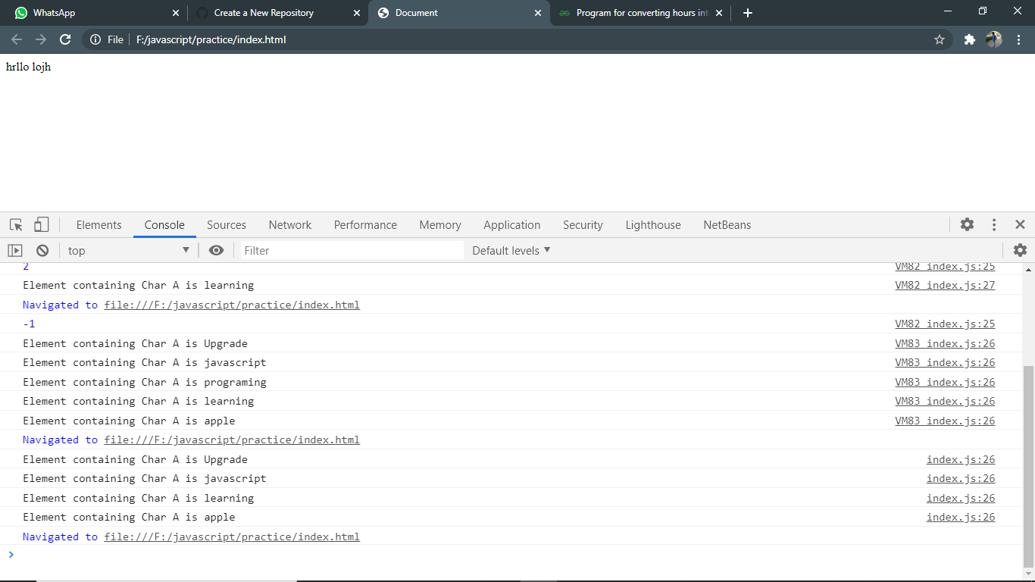

5. Print Array in reverse order

arr = ["lets","Upgrade","javascript","programing","learning","webtech"];

console.log(arr);

for(let i=arr.length-1; i>=0; i--){

    console.log("Element is: ",arr[i]);

}

Output:

